PROJECT 6: BUILD A TURN_BASED BOARD GAME

I. Summary
Build a game, that allows 2 users play together using mouse click to move the characters. There are two characters, some weapons & obstacles being placed randomly on the map. Players move in turn and collect the weapon to get new strength. If two characters stand next to each other, then fight.
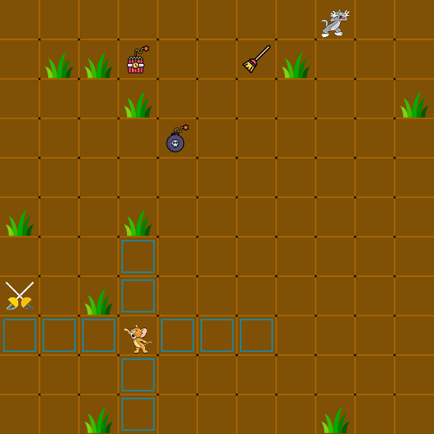

II. Stakeholders

1. Client / User : Any one, who wants to play this game
2. Designer / Dev: Thai Son Dang
3. Evaluator: OpenClassroom

III. Goals

1. Design the look for the game.
2. Find and collect game icons that needed in the game.
3. Draw the grid on canvas.
4. Randomly place Characters and objects on the map.
5. Make the Characters move.
6. Have the characters swaping weapons.

IV. Technical specifications

1. Design
Two separated <div> element to display infomation about players (blood, strength, shield,...)
Using TOM & JERRY characters and related objects to make the game be familiar to user and attract user to play.

2. Choice of technologies.
HTML: for design the frame of the website
CSS & SCSS: to style the look of the app. SCSS make the code more maintainable and easy to manage.
CANVAS in HTML: to draw the characters and grid. Also allowing to interact with the mouse.
Javascript & jQuery: javascript code allows to draw images, shapes on the Canvas element.
jQuery is a JS-library that allow to write less, do more.
Trello & Git-Github: to manage the code and task more easily.

V. Timeline
STEPS | SUB-STEPS | DURATION | QUESTIONS | ANSWERS | NOTES
Design the look for the game | make a wire-frame on paper / online. | 2 days
Design the look for the game | find and collect game icons | 1 day
Design the look for the game | create and organize game folders | 1 day
Design the look for the game | write HTML and CSS to make the first prototype of the app | 2 days
Draw grid and images on the canvas | read articles about Canvas and how to draw things on Canvas | 2 days
Draw grid and images on the canvas | draw the background for the game (brown) |  |  |  | ctx.fillRect()
Draw grid and images on the canvas | draw grid (lines) on the canvas |  |  |  | ctx.moveTo()  ctx.lineTo()  ctx.stroke()  using for loop
Draw grid and images on the canvas | draw images on the canvas |  |  |  | ctx.drawImage()
Make the characters move | write the function to get coordination of any point on the canvas [x, y] when user clicks on that. |  | how? | cellWidth  boardWidth  mouseX  mouseY  point A[x, y]  x = Math.floor(mouseX / cellWidth)  y = Math.floor(mouseY / cellWidth)
Make the characters move | function to calculate the path from A to B |  | if moving from A to B, which points must the character pass through? | A, B are on the same row / column. So using for loop we can calculate the path.
Make the characters move | function to validate the path |  | since the characters can't go through the obstacles. So if we have a path, we must check if the path is valid or not | check if there is any point in the path, which is a obstacle or other player.  If so, then the path is valid => no move
Make the characters move | method moveTo() of the characters. |  | after the path is valid, we make the move. | - clear the canvas  - draw new character on the target position
make the character swap weapon | function to check if there is a weapon inside the moving path. |  |  | if there is a weapon in the path. Then get the ID of the weapon and assign new Weapon to characters.  Lastly, replace that weapon with the old weapon of player.

NOTES:

1. How to manage positions of player and objects on the canvas
Using 2D-arrays. A element inside 2D-array have 2 indexes. It can be accessed to by call Array[ row ][ column ].
row and column here are exactly coordination of one point on the map and they are unique.
By storing corresponding values that represent objects, we can access the objects easily.

2. The characters and weapon can be at the same place on the map. So, which value do we store on that cell?
If in the game, things can be at the same places, we need to store them in separated 2D-arrays. Only things with different places and never be on the same places can be store in the same 2D-array.

